Elements & Principles of Art

The Mnemonic Device we use for the Elements of Art is:

Sam Can View The Land From Space

The Mnemonic Device we use for the Principles is:

BRUCE PM

Elements of Art
(building blocks of visual art)

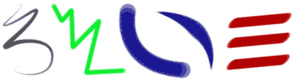

Line- Line is the path of a point moving through space.

Shape / Form- Shape implies spatial form and is usually perceived as two-dimensional. Form has depth, length, and width and resides in space. It is perceived as three-dimensional
Organic shape-irregular sides found in nature

Geometric shapes-have regular sides and are measurable.

Color- Colors all come from the three primaries and black and white. They have three properties – hue, value, and intensity.

Value- Value refers to the lightness and darkness of a color. It can be used to create the illusion of objects appearing three dimensional.

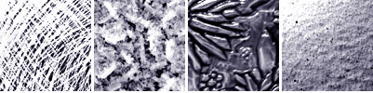
Texture- Texture refers to the tactile qualities of a surface (actual) or to the visual representation of such surface qualities (implied).

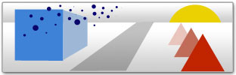
Space / Perspective- Space refers to the area in which art is organized. Perspective is representing a volume of space or a 3-dimensional object on a flat surface.
Positive Space-is of the subject
Negative Space- Empty Space

Principles of art

(use or arrangement of the building blocks of visual art)

Pattern-Pattern refers to the repetition or reoccurrence of a design element, exact or varied, which establishes a visual beat.

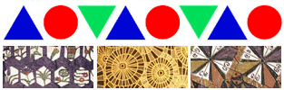

Rhythm / Movement
Rhythm or movement refers to the suggestion of motion through the use of various elements.
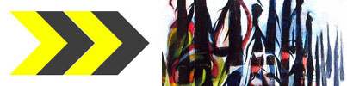
A repeated element creates a pattern. A pattern repeated creates movement. Repetition of movement creates Rhythm.

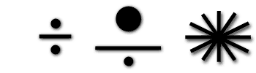
Balance- Balance is the impression of equilibrium in a pictorial or sculptural composition. Balance is often referred to as symmetrical, asymmetrical, or radial.

Unity- Unity is achieved when the components of a work of art are perceived as harmonious, giving the work a sense of completion.
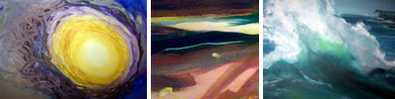

Emphasis- Emphasis refers to the created center of interest, the place in an artwork where your eye first lands.

Contrast-The differences in any of the elements and principles

Composition (REFER BELOW)

TERMS WE’VE USED THIS YEAR

Proportion / Scale- Proportion is the size relationship of parts to a whole and to one another. Scale refers to relating size to a constant, such as a human body.

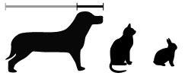

Rule of Thirds- A compositional strategy creating interest in an artwork. Moving the focal point away from the center and onto the “thirds” of the grid.
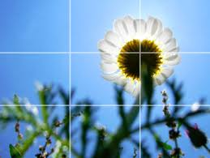

ART CRITIQUE
DESCRIBE-Tell what you see and where you see it, very specific details of everything in the image. (ex: In the foreground to the right there is a green and blue tree that extends from the right to left side of the image etc.)
ANALYZE- Using the Elements & Principles, tell where you see them and how they are used.
INTERPRET- What do you think the artist is trying to convey, and why? What concrete evidence in the image makes you think that?
EVALUATE-Is the piece successful, why or why not? Discuss “The Rule of Thirds,” What type of balance it uses, Use of space and a few elements/principles and how they’re used effectively.

