Inside the Earth
Unit Study Guide and Notes
Chapter 1: Plate Tectonics

Section 1-1: Earth’s Interior (p. 14-24)

Vocabulary
- Geologist—Scientists that study the forces that make and shape ___________________.
- __________________—The study of planet Earth.
- ______________________Wave—A vibration traveling through Earth carrying the energy released during an earthquake.
- Pressure—The amount of __________________ pushing on an area.
- Crust—Layer of ________________ that forms Earth’s outer surface.
- Basalt—A dark, dense igneous rock found in the __________________________ crust.
- Granite—Usually a light colored rock found on Earth’s ___________________________crust.
- Mantle—The layer of hot solid material between the __________________ and the _____________.
- ____________________________—A rigid layer made up of upper part of the mantle and the crust.
- Asthenosphere—Soft layer of the ______________________ on which the lithosphere floats.
- ____________________Core—Layer of molten iron and nickel that surrounds the inner core.
- Inner Core—Solid iron and nickel in the ____________________ of the earth.

Notes
- Scientists cannot travel inside Earth to explore it. So scientists must learn about Earth’s interior, or ______________________, in other ways.
- Scientists use drills to get _______________________________________ from inside Earth. The rock samples help scientists learn what conditions were like inside Earth when the rocks formed.
- Geologists study how seismic waves travel through Earth. Seismic (SYZ mik) waves are waves made by __________________________. Seismic waves show that Earth is made up of layers like an onion.

Review Questions (Answer the following questions. Use your textbook and the ideas in your notes to help you.)
1. Circle the letter(s) of any way that scientists can learn about Earth’s interior.
a. travel inside Earth and explore it directly
b. study rock samples from inside Earth
c. peel away Earth’s layers like an onion
d. use seismic waves from earthquakes

2. Is the following sentence true or false? Earth is made up of layers. ______________________

Notes
- Earth has ___________________ main layers. The crust is the ________________ layer. The ____________________ is the middle layer. The ________________ is the inside layer.
- Temperature ________________________ from the crust to the core. It is very hot inside the Earth. One reason it is so hot is that some substances inside the Earth give off __________________.
- Pressure also increases from crust to core. Pressure is caused by a force _______________ on an area. There is great pressure inside Earth because of all the _____________ pressing down from above.

Review Questions (Answer the following questions. Use your textbook and the ideas in your notes to help you.)

3. Is the following sentence true or false? Earth’s temperature decreases from the crust to the core. _______________________________

4. The layer of Earth that is under the greatest pressure is the ____________________.

5. Fill in the blanks in the diagram about Earth’s layers. 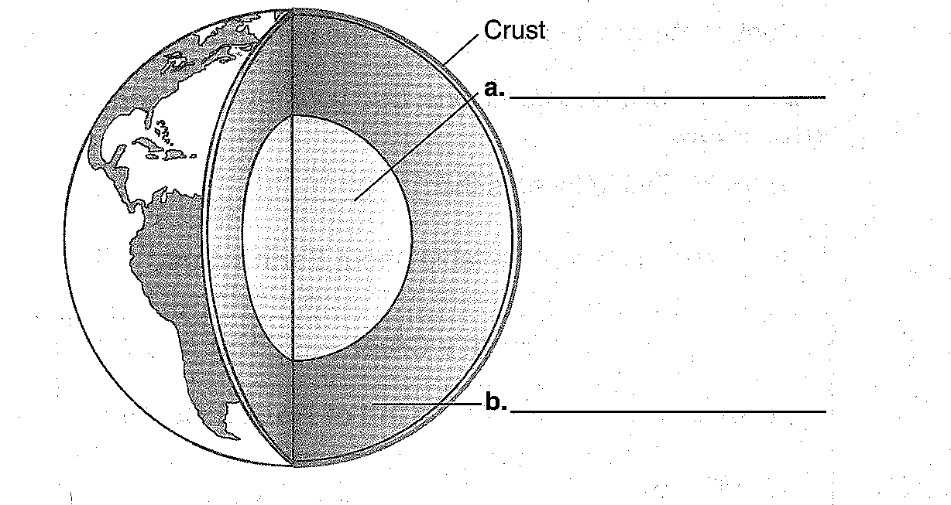
Notes
- The _____________________ is a layer of rock that forms Earth’s outer skin. The crust is Earth’s _____________________ layer. It is only 5 to 70 kilometers thick.
- The crust that makes up the ocean floors is called oceanic crust. Oceanic crust is made mostly of a rock called ___________________.
- The crust that makes up the continents is called _________________________ crust. Continental crust is made mostly of a rock called granite.
- Continental crust is __________________________ than oceanic crust.
- The ___________________________ is the layer below the crust. The mantle is Earth’s thickest layer. The mantle has ______________________ parts.
- The top layer of the mantle, along with the crust, is the ___________________________. The top layer of the mantle is hard rock.
- The _____________________ layer of the mantle is the asthenosphere ( as THEN uh sfeer). The middle layer is ________________ rock, like hot road tar.
- The bottom layer of the mantle is called the _________________ mantle. It is also hard rock.
- The core is Earth’s inside layer. The core has ____________ layers: the outer core and the inner core.
- The ______________________________ is made of liquid metal. The liquid metal flows in currents. The currents make Earth act like a giant ____________________, with north and south poles that attract iron.
- The inner core is made of solid metal. The inner core is solid because it is under so much ________________________.
Review Questions (Answer the following questions. Use your textbook and the ideas in your notes to help you.)
6. Earth’s outer layer is the ____________________.
7. Fill in the blanks in the table about Earth’s crust.
Earth’s Crust
Part of Crust | Kind of Rock It Contains
Oceanic crust | a. _____________________________
b. ___________________________________ | granite

8. Is the following sentence true or false? Oceanic crust is thicker than continental crust. _________________________
9. Circle the letter of each sentence that is true about the mantle.
a. The mantle is the layer below the crust.
b. The mantle is Earth’s thinnest layer.
c. The lower mantle is made of hard rock.
10. Match the name of each layer of Earth with its description.
_______ mantle a. Rigid layer that include the upper part
of the mantle and the crust.
_______ lithosphere b. Layer of hot rock between the crust and
the core.
_______ asthenosphere c. Soft layer just below the lithosphere.
11. Is the following sentence true or false? The asthenosphere floats on the lithosphere. ________________________
12. Circle the letter of each sentence that is true about Earth’s core.
a. The core is made mostly of iron and nickel.
b. The core is Earth’s inside layer.
c. The core is a giant magnet.
13. Is the following sentence true or false? Earth acts like a giant magnet because of currents in the outer core. _________________________

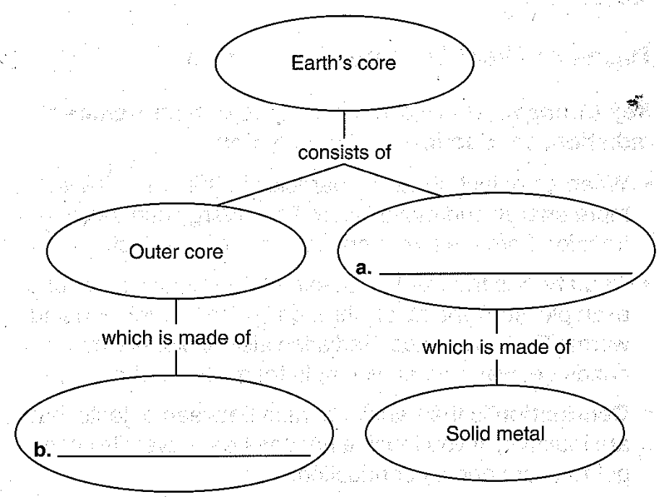
14. Fill in the blanks in the concept map about Earth’s core.

Section 1-2: Convection Currents and the Mantle (p. 25-27)

Vocabulary

- Heat Transfer—The movement of energy from a ____________________ object to a cooler one.
- _____________________________—The transfer of energy through empty space.
- ______________________________—Heat transferred by direct contact of particles of matter.
- Convection—Heat transfer by the movement of heated ______________________.
- Density—How much mass there is in a volume of a substance.
- Convection ______________________—The flow that transfers heat from one part of a fluid to another.
Notes
- When an object heats up, particles in the object have more energy and move _______________. This energy can travel, or transfer, from a ___________________ object to a ____________________ object.
- Radiation is the transfer of energy through ______________________. For example, sunlight travels through space by radiation and warms Earth’s surface. _____________________________ also explains why your hands get warm when you hold them near a fire.
- Conduction is the transfer of heat between objects that are _______________________. If you touch a hot pot, heat travels from the pot to your hand by conduction.
- ____________________________ is the transfer of heat by the movement of particles in ____________ such as water. Moving particles transfer heat throughout the fluid.

Review Questions (Answer the following questions. Use your textbook and the ideas in your notes to help you.)
15. The kind of heat transfer that warms Earth’s surface on a sunny day is _____________________.
16. Circle the letter of an example of conduction.
a. A sidewalk gets hot on a sunny day.
b. A pot gets hot on a stove.
c. A bench gets hot near a campfire.
17. The transfer of heat by the movement of particles in fluids is _____________________________.

Notes
- Remember, convection is the transfer of heat by the movement of particles in fluids. This movement of particles is called ______________________________________________.
- A convection current starts when there are differences in _______________________________ and density in a fluid. Density is the amount of mass in a given volume of a substance. A high-density substance feels heavy for it’s size.
- Suppose you put a pot of soup on a stove. The soup at the bottom of the pot gets warm first. Because it is warmer, the soup at the bottom is __________________ dense than the cooler soup above it. So the warmer soup _______________________. At the same time, the cooler, denser soup sinks to the bottom of the pot.
- The cooler soup now at the bottom gets ________________________, and the process repeats. A constant flow of particles begins. Warmer soup keeps rising, and cooler soup keeps sinking. This movement of particles ________________________ heat throughout the soup.

Review Questions (Answer the following questions. Use your textbook and the ideas in your notes to help you.)
18. Is the following sentence true or false? A convection current starts when there are differences in temperature and volume of a fluid. ____________________________

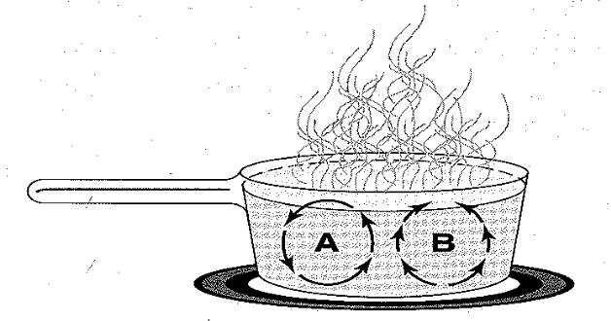
19. Circle the set of arrows that shows how a convection current flows through the liquid in the pot.

Notes
- The heat inside Earth causes convection currents in the ___________________ and outer core.
- Convection currents inside Earth are like convection currents in the pot of soup. Hot materials at the bottom rise to the top. _____________________ materials sink to the bottom.
- Convection currents in the mantle move very _____________________. This is because the mantle is made of solid rock.
- Remember, Earth is like a giant magnet because of currents in the __________________________. Those currents are convection currents.

Review Questions (Answer the following questions. Use your textbook and the ideas in your notes to help you.)
20. The layers of Earth that have convection currents are the mantle and ______________________.

21. Circle the letter of the sentence that correctly describes how convection currents move inside Earth.
a. Hot materials rise, while cooler materials sink.
b. Hot materials sink, while cooler materials rise.
c. Hot materials move up or down, while cooler materials move sideways.

Section 1-3: Drifting Continents (p. 28-32)

Vocabulary
- ______________________—The name of the landmass in the theory that all the continents were joined at one time.
- Continental Drift—The idea that the continents slowly _________________ over the earth’s surface.
- ______________________—Any trace of an ancient organism that has been preserved in rock.

Notes
  - Some continents are shaped like ____________________ pieces. For example, the west side of Africa and the east side of South America look like matching puzzle pieces.
  - Scientist Alfred Wegener (VAY guh ner) tried to explain why continents are shaped this way.
  - Wegener thought that Earth had one big continent about 300 million years ago. The big continent broke into smaller pieces and formed smaller continents. The continents slowly _____________________ apart. Wegener called this __________________________________________________.
  - Wegener named this supercontinent _______________________________, meaning “all lands.”
  - Evidence shows that continental drift really happened. ____________________________________ in Africa and South America line up as if they were once part of the same mountain range. Also, _____________________ of plants and animals have been found to support Wegener’s theory. The plant Glossopteris was found in rock in Africa, India, Australia, and Antarctica. The seeds would be too large to have been carried to the continents as they are today. Other evidence shows that continents’ ________________________ have changed. This could happen if continents had drifted.

Review Questions (Answer the following questions. Use your textbook and the ideas in your notes to help you.)

22. Wegener called the slow movement of continents _____________________________________.
23. Circle the letter of the drawing that shows how Wegener thought South American and Africa were once joined as part of a single, giant continent. 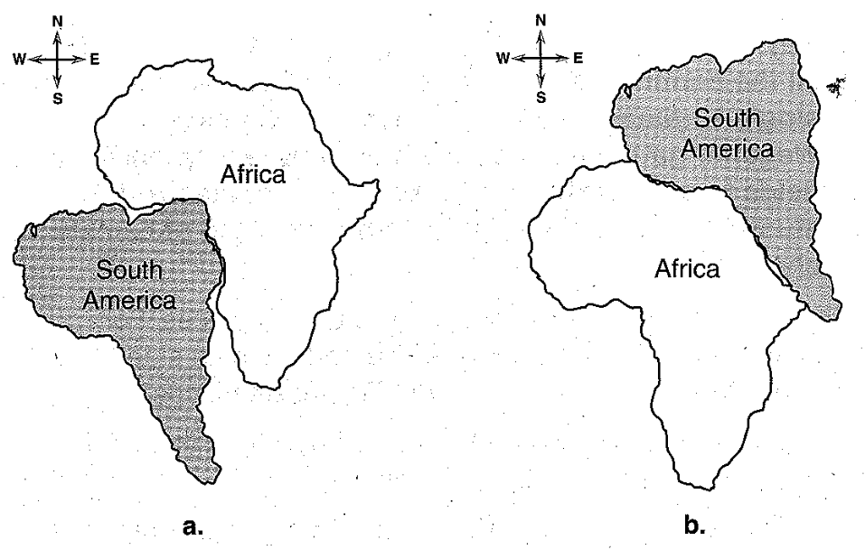
24. Complete the concept map.
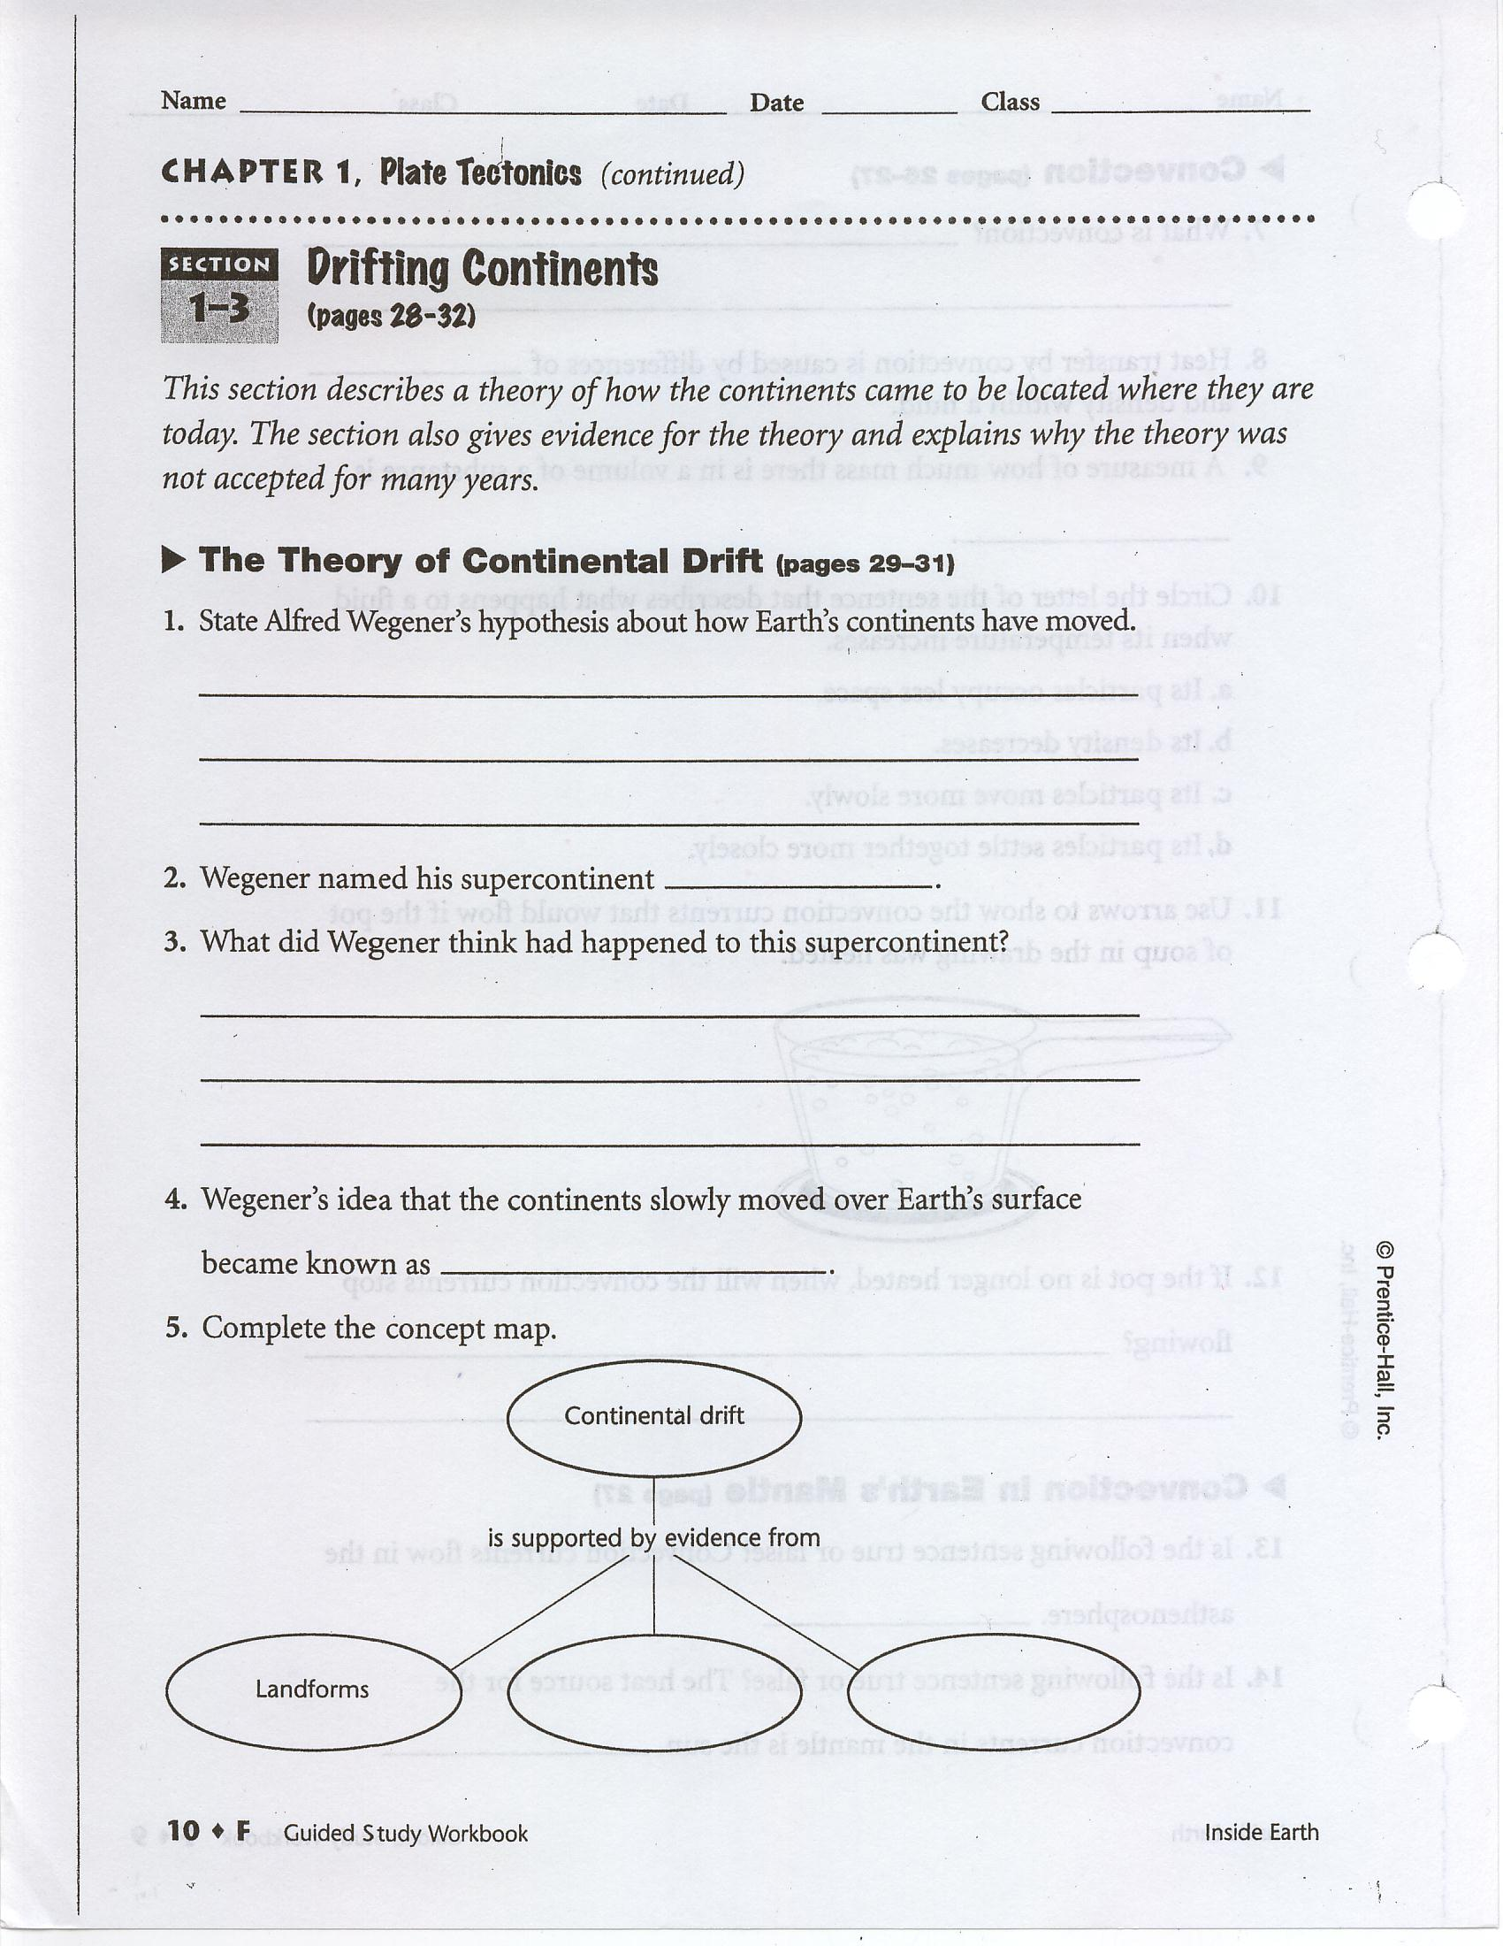

Notes
- Wegener could not explain what causes continental drift. So most other scientists of this time thought he was ____________________.
- Wegener used his idea of continental drift to explain how mountains form. Wegener thought mountains form because drifting continents ________________ into each other. When this happens, edges of the continents crumple. The crumpled edges form ________________________________.

Review Questions (Answer the following questions. Use your textbook and the ideas in your notes to help you.)
25. Is the following sentence true or false? Wegener’s ideas were accepted by most other scientists of his time. __________________________

26. Circle the letter of the sentence that describes how Wegener thought mountains form.
a. Earth slowly cools and shrinks.
b. Continents drift apart.
c. Continents bump into each other.

Section 1-4: Sea-Floor Spreading (p. 33-41)
Vocabulary
- Mid-Ocean Ridge— The ______________________ chain of mountains in the world.
- Sonar—A device that bounces sound waves off underwater objects then records the _____________________ of the sound waves.
- Sea-Floor Spreading—The process of molten material being added to the _________________ crust.
- Deep-Ocean ______________________—A deep valley along the ocean floor through which oceanic crust slowly sinks towards the mantle.
- _____________________________—The process by which the oceanic crust sinks beneath a deep-ocean trench and back into the mantle at a convergent plate boundary.

Notes
  - Since the mid-1900s, scientists have used __________________ to study the ocean floor. Sonar is a device that bounces ___________________waves off underwater objects. The longer it takes the sound waves to bounce back, the farther away the objects are.
  - Using sonar, scientist found long mountain ranges on the ocean floors. Scientists call the mountain ranges __________________________________________. Mid-ocean ridges run through the middle of all ________________________, creating the longest chain of mountains in the world.
  - In a few places, mid-ocean ridges poke above the surface and form _____________________. Iceland is the top of a mid-ocean ridge in the North Atlantic Ocean.
Review Questions (Answer the following questions. Use your textbook and the ideas in your notes to help you.)
27. Is the following sentence true or false? Scientists use sound waves to study the ocean floor. ________________________
28. Circle the letter of each sentence that is true about mid-ocean ridges.
a. Mid-ocean ridges are mountain ranges on the ocean floor.
b. Mid-ocean ridges sometimes form islands.
c. Mid-ocean ridges are found only in the Atlantic Ocean.
d. Mid-ocean ridges form the shortest chain of mountains in the world.

Notes
- Sea-floor spreading is a process that slowly adds new rock to the __________________________. Scientist Harry Hess came up with the idea of sea-floor spreading in 1960.
- Here is how sea-floor spreading works. In the center of the mid-ocean ridge, melted rock pushes up through ___________________ in the ocean floor. The melted rock pushes older, solid rock away from both sides of the ridge. The melted rock _______________ and forms new solid rock at the center of the ridge.
- This process keeps repeating. Slowly, the ocean floor is pushed farther and farther away from both sides of the ______________________________________________________. At the same time, new rock keeps adding to the ocean floor in the __________________ of the ridge.
- In the 1960s, scientists tried to find evidence of sea-floor spreading. They found evidence from _______________________ sources.
- Scientists used a submarine to get rocks from a mid-ocean ridge. They found rocks shaped like toothpaste squeezed from a tube. This could only be caused by ________________ ___________________ from lava that has hardened quickly along cracks of the mid ocean ridge.
- Scientists also found evidence from _______________________________________. Strips of rock on the ocean floor showed that there had been the reversal of Earth’s magnetic poles.
- Scientists used a ___________________ to get rocks from below the ocean floor. Rocks closest to the mid-ocean ridge were the ________________________. Rocks farthest from the mid-ocean ridge were the oldest.

Review Questions (Answer the following questions. Use your textbook and the ideas in your notes to help you.)
29. The process that slowly adds new rock to the ocean floors is called _________________________.

30. The diagram shows sea-floor spreading. Circle the letter of the two arrows that show the directions in which the sea floor is spreading.
a. A and B b. A and C c. B and C

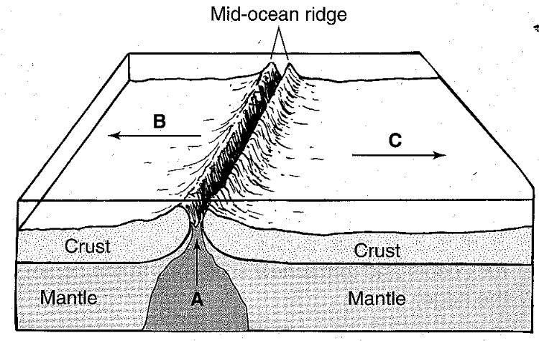
31. List the three types of evidence for sea-floor spreading.
a. ____________________________________________ b. ____________________________________________
c. ____________________________________________

32. Circle the letter of each sentence that correctly describes evidence for sea-floor spreading.
a. Melted rocks have hardened again and again at mid-ocean ridges.
b. Rocks closest the mid-ocean ridges are the oldest.
c. Rocks farthest from mid-ocean ridges are the oldest.
d. Earth’s magnetic poles have reversed.

Notes
- Sea-floor spreading makes the ocean floor get ___________________. New rock keeps forming at mid-ocean ridges. Old rock keeps getting pushed farther and farther away from both sides of the ridges.
- After million of years, old rock reaches underwater canyons, called deep-ocean _________________________. At a deep-ocean trench, the rocky crust of the ocean floor bends downward and sinks into the ____________________. This process is called subduction. Subduction occurs because the ____________ ________________ oceanic crust sinks beneath the less dense ________________________________ crust.
- Sea-floor spreading and subduction work together. They keep the ocean floors moving like conveyor belts in an airport. As new rock is added to the ocean floors, old rock __________________________. Overall, the size of the ocean floors does not change very much.

Review Questions (Answer the following questions. Use your textbook and the ideas in your notes to help you.)
33. The process in which ocean floors sink into the mantle is called ___________________________.
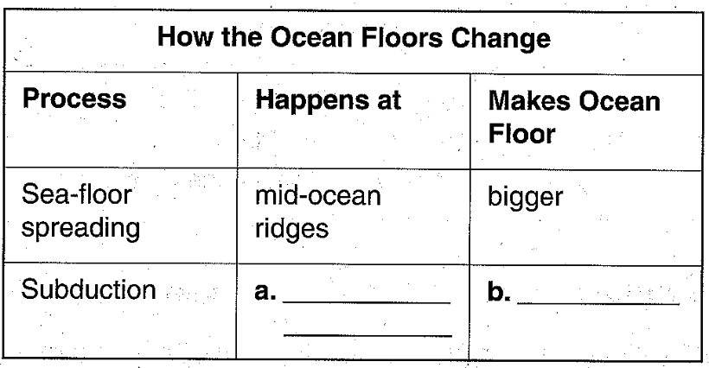
34. Fill in the blanks in the table about changes in the ocean floors.

35. Is the following sentence true or false? Overall, the size of the ocean floor does not change very much. __________________________

Section 1-5: The Theory of Plate Tectonics (p. 42-49)

Vocabulary
- Plate—A section of the ________________________ that slowly moves over the asthenosphere, carrying pieces of oceanic and continental crust.
- Scientific ___________________—A well tested concept that explains a wide range of observations.
- Plate Tectonics—The theory that pieces of the Earth’s lithosphere are in constant motion driven by the _________________________________________ in the mantle.
- Fault—Breaks in the Earth’s _____________________ where rocks have slipped past each other.
- Transform Boundary—Where plates slip in _______________________ directions.
- _____________________ Boundary—Place where two plates move apart.
- Rift Valley—A deep valley that forms when two _____________________ move apart.
- Convergent Boundary—Place where two plates ________________________________________.

Notes
  - Earth’s lithosphere is broken into many jagged pieces. The surface is like the shell of a hard-boiled egg that has been dropped. The pieces of Earth’s surface are called _________________. Plates carry continents, ocean floors, or both.
  - The theory of plate tectonics (tek TAHN iks) says that Earth’s plates move because of convection currents in the _______________________. Currents in the mantle carry plates on Earth’s surface, like currents in water carry boats on a river.
  - Plates can meet in __________________ different ways. Plates may pull apart, push together, or slide past each other. Wherever plates meet, you usually find __________________________, mountain ranges, or deep-ocean trenches.
  - A plate boundary is where two plates meet. __________________ form along plate boundaries. A fault is a break in Earth’s crust where blocks of rock have slipped past each other.
  - Where two plates move ____________________, the boundary is called a divergent boundary. A divergent boundary between two oceanic plates forms a ___________________________________. A divergent boundary between two continental plates forms a deep-valley called a rift valley.
  - Where two plates _______________________________________, the boundary is called a convergent boundary. A convergent boundary between an oceanic plate and a continental plate or between two oceanic plates forms a deep-ocean trench. A convergent boundary between two continental plates forms a ____________________ ____________________.
  - Where two plates slide past each other in opposite directions, the plate boundary is called a _________________________ boundary. At a transform boundary, _________________________ may occur.
Review Questions (Answer the following questions. Use your textbook and the ideas in your notes to help you.)
36. The lithosphere is broken into separate sections called ______________________.

37. Is the following sentence true or false? Earth’s plates carry only the continents. ___________

38. Circle the letter of the sentence that states the theory of plate tectonics.
a. Earth’s plates cannot move because they are made of solid rock.
b. Earth’s plates move because of convection currents in the mantle.
c. Earth’s moving plates cause convection currents in the mantle.

39. Match each term with its definition.
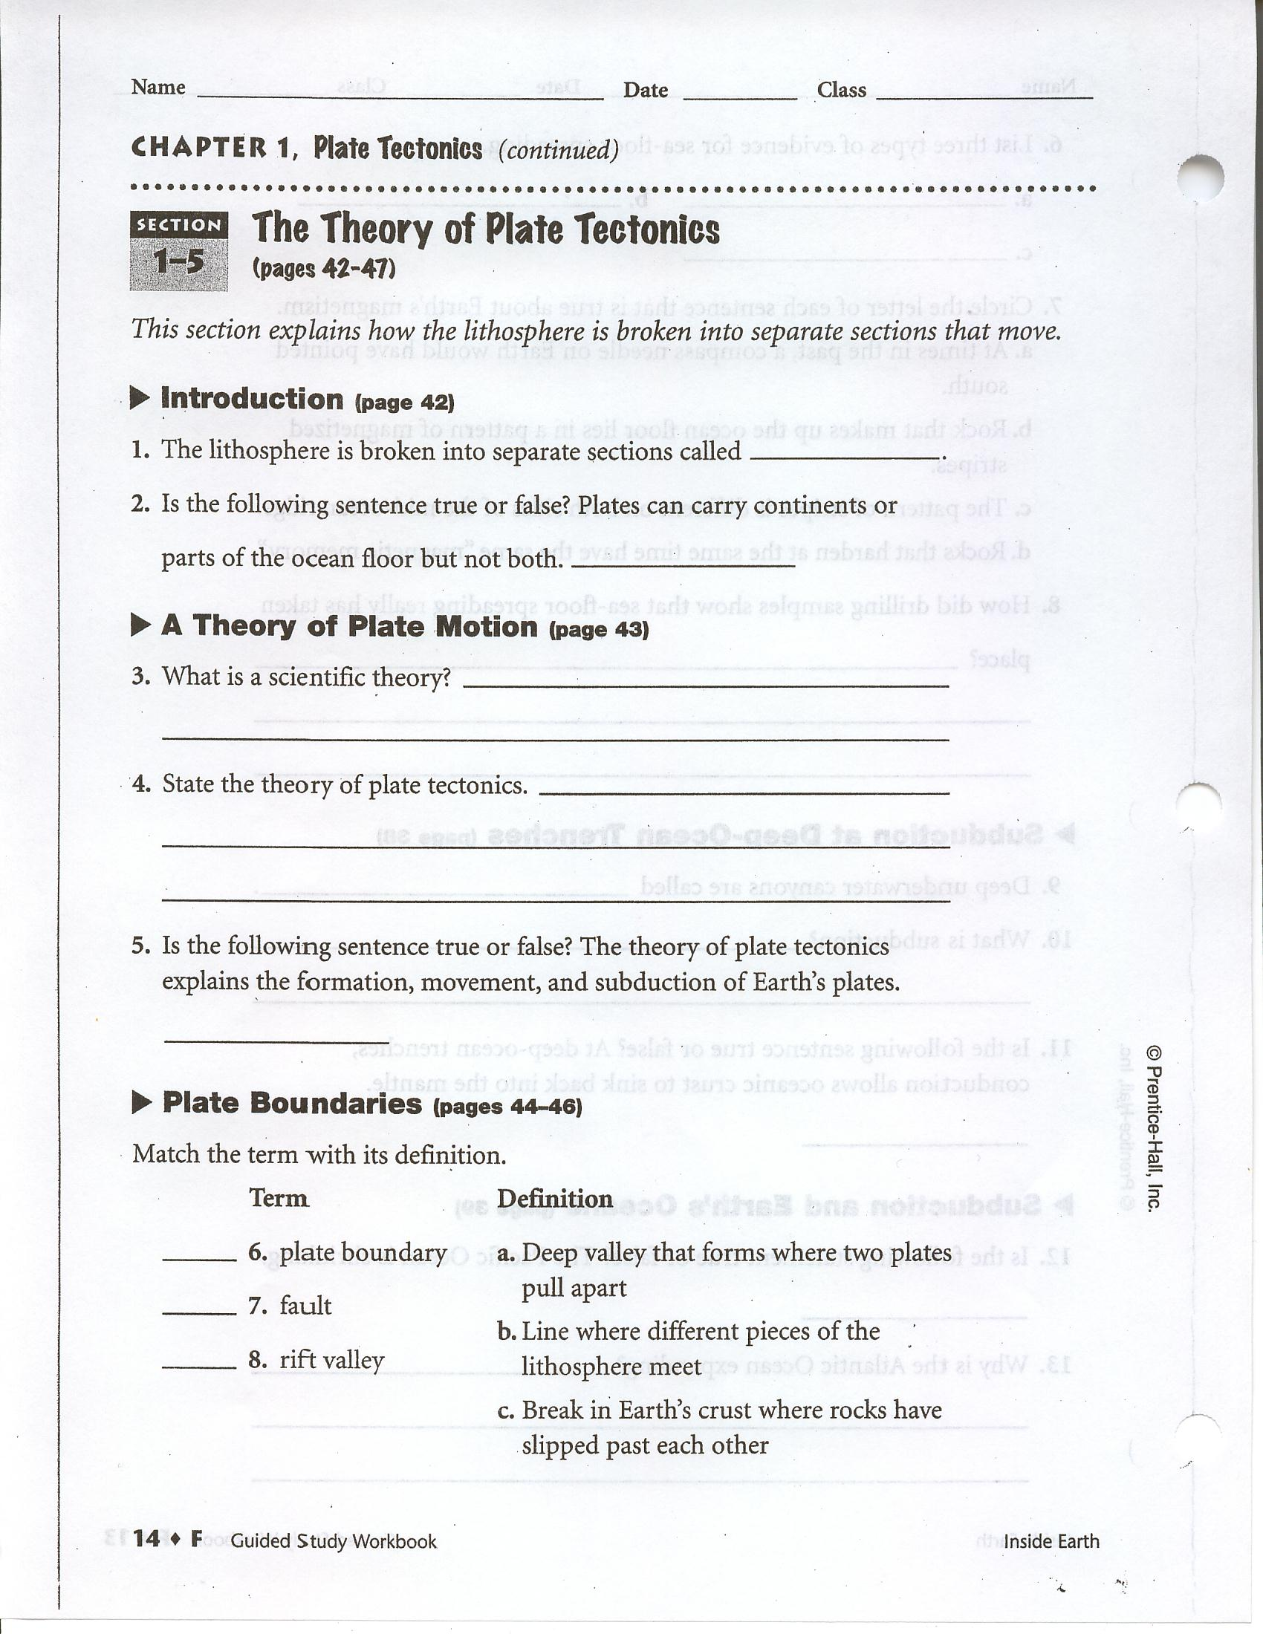
40. Complete the table.
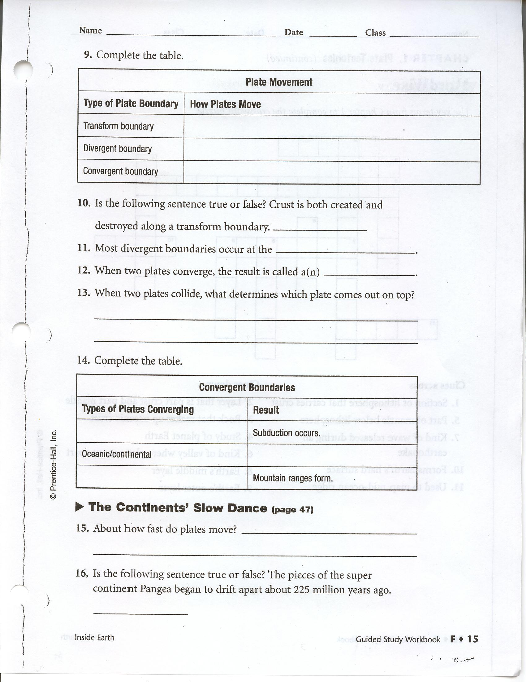

Chapter 2: Earthquakes

Section 2-1: Earth’s Crust in Motion (p. 54-63)

Vocabulary
- _____________________________ : The shaking and trembling as a result of rock moving beneath earth’s surface.
- Stress: A ____________________ that acts on rock that changes its shape or volume.
- ________________________: Stress that pushes a mass of rock in two opposite directions.
- _______________________: Stress that pulls on the crust causing it to be thinner in the middle.
- ___________________________: Stress that squeezes rock until it folds or breaks.
- Fault: A break in Earth’s crust where slabs of __________________ slip past each other.

Notes
- When Earth’s plates move, rocks are pushed and pulled. The pushes and pulls are called ________________________.
- Stress adds _______________________ to rocks. Rocks keep storing the energy until they cannot stand any more stress. Then the rocks break or change shape.
- Tension is stress that _________________ and ________________________ rocks. Tension makes rocks ____________________ in the middle. Tension happens when two rocks move ______________________.
- Compression is stress that __________________________ rocks. Compression makes rocks fold or break. Compression happens when two plates ______________ ______________________________.
- Shearing is stress that ____________________ the rocks in opposite directions. Shearing makes rocks break, slip apart, or change shape. Shearing happens when two plates _______________ ________________ each other in opposite directions.
- A _________________________ is a break in Earth’s crust where rocks are under stress.
- There are ________________________ different types of faults: normal faults, reverse faults, and strike-slip faults. Each type is caused by a different kind of _____________________ on rocks.

Review Questions (Answer the following questions. Use your textbook and the ideas in your notes to help you.)
41. Circle the letter of the choice that describes how stress affects rocks.
a. Stress adds energy to rocks.
b. Stress uses up the energy in rocks.
c. Stress squeezes energy out of rocks.

42. Read the words in the box. In each sentence below, fill in one of the words.
shearing compression stress

folding tension
a. Pushes and pulls on rocks are called __________________________________.
b. Stress that makes rocks fold is called _________________________________.
c. Stress that stretches rocks is called _______________________________.
d. Stress that makes rocks slip apart or change shape is called ______________________________.

43. Fill in the blanks to label the kinds of stress shown.
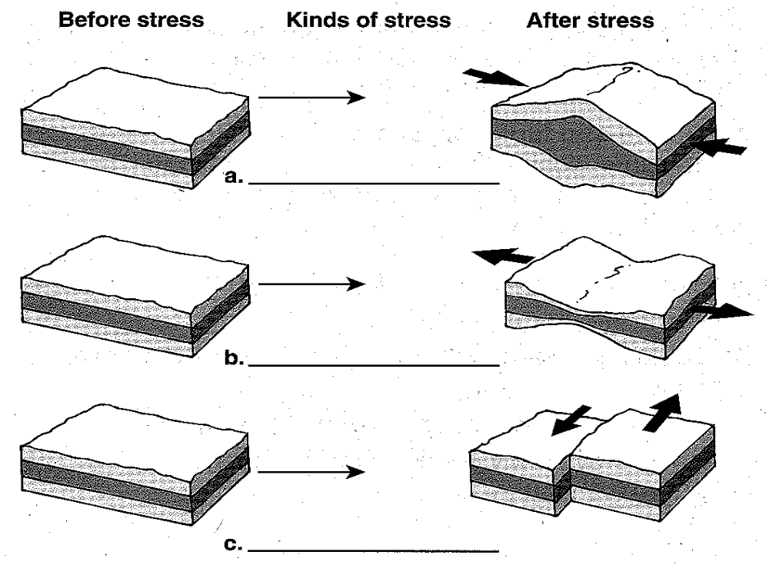

44. Circle the letter of the choice that explains what causes a fault.
a. Stress increases on rocks until they move.
b. Energy slowly drains away from rocks.
c. Rocks heat up and melt.

Section 2-2: Measuring Earthquakes (p. 64-71)

Vocabulary

- _____________________—The point under the Earth’s surface where rock breaks, triggering an earthquake.
- _______________________—The point on the surface directly above the focus.
- Seismic waves—Vibrations traveling through the Earth carrying energy released by an ________________________________.
- Seismograph—A device that records ground movements caused by ____________________ waves as they move through Earth.
- _____________________ scale—A scale that rates earthquakes based on their intensity and how much damage they cause.
- _____________________scale—A scale that rates seismic waves as measured by a particular type of seismograph. This scale rates the size of seismic waves.
- Moment magnitude scale—A scale that rates earthquakes by estimating the total __________________ released by an earthquake.

Notes
- An earthquake is the shaking that results when rocks move inside Earth. An earthquake is caused by _________________ along a fault. Stress increases until the rocks break and release stored __________________.
- The place where rocks break and cause an earthquake is called a __________________. The point on the surface directly above the focus is called the _____________________________.
- Earthquakes cause waves, called ____________________ waves, to travel through Earth. Seismic waves carry the energy released by the rocks. This energy is carried away from the focus, through Earth’s interior, in all directions. There are _________________ kinds of seismic waves: P waves, S waves, and surface waves.
- P waves (primary waves) move rocks ________________ and _________________, like a wave passing through a spring toy when you push the coils. P waves are the ______________________ seismic waves.
- S waves (secondary waves) move rocks ___________ and _______________, like a wave passing through a rope when you flick it. S waves travel move slowly than P waves but do more _____________________.
- Surface waves are __________________________ P waves and S waves that travel along Earth’s surface. Surface waves are the ___________________________ waves, but they also do a lot of damage.

Review Questions (Answer the following questions. Use your textbook and the ideas in your notes to help you.)
45. When the ground shakes because rocks have moved inside Earth, it is called a(n) _________________________________.

46. Is the following sentence true or false? Seismic waves carry the energy of an earthquake away from the focus in all directions. ______________________________

Notes
- The Mercalli scale is based on the amount of ______________________ an earthquake does. For example, a weak earthquake only rattles the dishes. A strong earthquake can _______________________ buildings.
- The Richter scale is based on the size of the __________________________________. A stronger earthquake makes bigger seismic waves. An instrument called a _____________________________ measures the size of seismic waves.
- The moment magnitude scale is based on the amount of ______________________ an earthquake releases. The amount of energy is based on many things, including the size of the __________________________________________.

Review Questions (Answer the following questions. Use your textbook and the ideas in your notes to help you.)
49. An instrument used to measure the size of seismic waves is a(n) ____________________________.

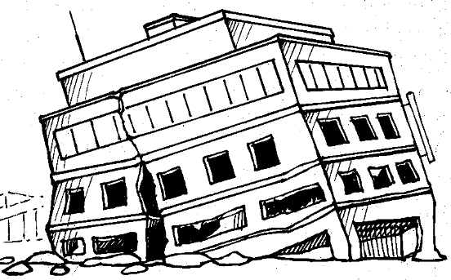
50. Which way of measuring earthquake strength is based on the kind of information shown in the drawing? _________________________________

51. Fill in the blanks in the table about ways to measure earthquake strength.
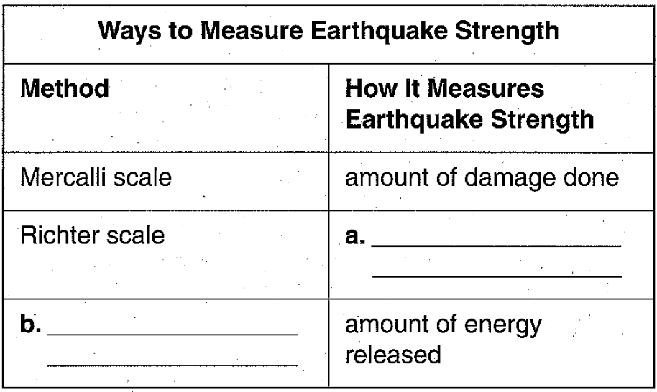

Notes
- The epicenter is the point on the surface that lies directly __________________ an earthquake’s focus. Scientists use P waves and S waves to find an earthquakes epicenter.
- P waves travel ______________________ than S waves. So P waves arrive at a seismograph sooner than S waves. The longer it takes S waves the reach the seismograph after the P waves have arrived, the __________________________________ the epicenter is.
- To find the exact location of the epicenter, you need seismographs in __________________ different places. You can draw a ____________________ around each seismograph to show how far the epicenter is from the seismograph. The point where all three circles cross is the ____________________________.

Review Questions (Answer the following questions. Use your textbook and the ideas in your notes to help you.)
52. Suppose it takes a long time for S waves to reach a seismograph after P waves have arrived. What does that tell you about the earthquake? Circle the letter of the correct answer.
a. The earthquake was strong.
b. The earthquake was close to the surface.
c. The earthquake was far away.

53. Is the following sentence true or false? One seismograph can tell you exactly where the epicenter of an earthquake is. _________________________

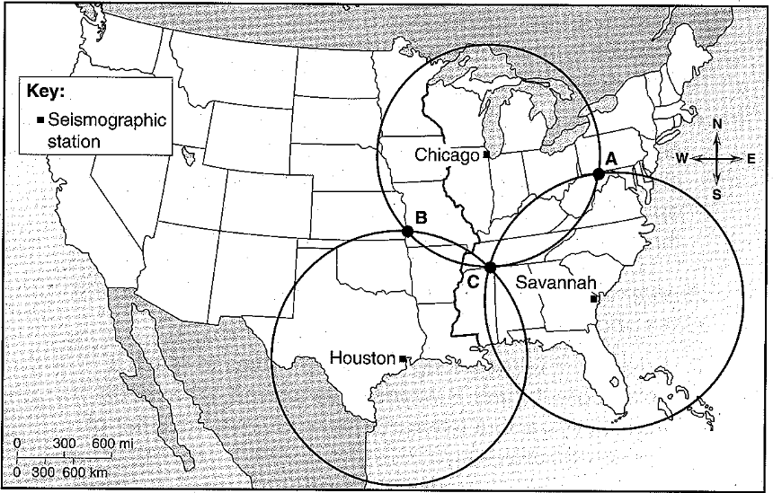
54. The map below shows three different seismographs in the United States. Each circle show the distance from a seismograph to the epicenter of an earthquake. Where is the epicenter? Circle the letter of the correct answer.
a. A
b. B
c. C

